(Approx. 798 words)

Back to Basics
Apple TV for More TV Viewing Options
By Jim Cerny, Columnist, Sarasota TUG, FL
April 2016 issue, Sarasota Technology Monitor
www.thestug.org / jimcerny123 (at) gmail.com

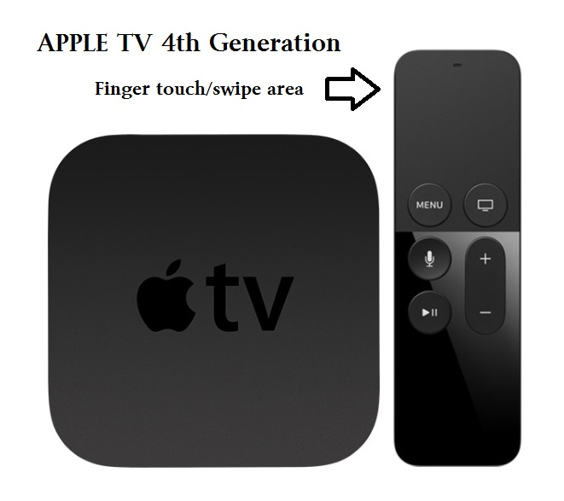

The Apple TV is a neat little box device you plug into a power outlet and into the back of your TV for a whole lot of fun TV viewing options. The latest version of Apple TV is called the “Fourth Generation” which, of course, has more possibilities and options than the previous versions. If you are an Apple user of other devices, such as an iPad and/or an iPhone, the Apple TV could be a really fun addition to your Apple family. It is in the price range of $150 to $200 depending upon the memory size.

What does it do? When you connect your Apple TV to your television set or computer monitor (you will need an HDMI cable to connect it which does not come with it) you will be prompted to connect it to your other Apple device(s) and your WIFI home network. When this happens, the following options or abilities would be available to you:

Download Apps (you know, programs and things) such as Netflix, Hulu, and YouTube (which are free) and you can search for movies, TV shows, or any other videos available through the internet. If you are looking for a particular movie, the Apple TV will find it and show you which of your apps has that movie available to you or, of course, you may also watch it through iTunes, probably for a charge. You can even download some relaxing videos such as a fireplace or aquarium just for atmosphere.
Music apps, such as the free Pandora, Spotify and others, will open up a whole world of music options for your listening enjoyment. You can “like” or “not like” whatever music you are listening to and Pandora, for example, will bring you more music you like based upon your choices. You can also make up playlists of your favorites by genre (classical, jazz, country, etc.) and pick your playlist to match your mood.

Games are an option too. There a many apps that will allow you to play games on your TV through the Apple TV box and more games are on the way. Apple is looking to compete with the big gamers by providing some game controllers for the Apple TV in the near future.

Photographs are fun and are even easier to share and show on your TV. You can set your iPhone or iPad to save your photos to the cloud and this makes your photos available to view using your Apple TV. Remember the “cloud” is a way of saving your stuff on the internet so that it can be available to your other devices which can also access the internet. Being an Apple product, naturally it works the best and easiest with your other Apple devices using your iTunes or Apple ID account.

Another fun ability of the Apple TV is to duplicate your display screen of your iPad and iPhone on your big screen TV. This comes in very handy for teaching my iPad class.

The set-up of the Apple TV out of the box is not difficult and will step you through the process. It comes with a nice remote control which you “swipe” and “click” with your finger to navigate through the settings and options. Please be prepared to “Ask Google” if you have any questions about the set-up. As I mentioned earlier, you will need to purchase an HDMI cable to connect it to your TV. You may not want to consider purchasing an Apple TV unless you also have at least one other Apple device, such as an iPhone or an iPad.

The Apple TV also comes with “Siri” – the voice recognition capability. This eliminates having to use the controller to key-in one letter at a time to do a search – just hold down the microphone button on the controller and ask it anything. Of course the Apple TV is capable of more uses than these (and more are coming) but they do give you a good idea to help you decide if an Apple TV would be good for you.

Overall, I think it is a very nice device with many possibilities. But I also caution that it is not for everyone. If you are interested, ask your friends or someone at your computer users group who has one, and “Ask Google” too, you will learn more of the possibilities. Like many devices, different people use it for different reasons. Maybe it would be something you would enjoy. It certainly is a big step closer to “cutting the cable” to your video provider and saving a bunch of money every month!

